FREE autism study
  Be good to your brain. Your body will thank you. |  | Free Non-Invasive Treatment from Dr. Dale Foster at Memphis Neurofeedback, LLC  Thanks to the sponsorship of a philanthropic charity dedicated to helping children, we are currently recruiting children between the ages of 6 and 17 who have a diagnosis of Autism Spectrum Disorder (ASD) for an Acoustical Neuro Modulation (ANM) and Neurofeedback (NF) in Autism Study.  - Goal: To further evaluate a combination of treatments already noted to have made significant difference in the development of children with ASD.  - Treatment: one hour, twice weekly minimum, a total of 12-14 sessions  - 6 non-invasive sound sessions +  6 EEG biofeedback sessions  - Free study, but $5.00 refundable fee collected for each session. If no sessions are missed, the money will be refunded in full.  - Results thus far: calming, improved sleep, increased focus and awareness, improved mood and communication, and reduction of number of symptoms related to anxiety

Dale S. Foster, PhD, QEEGD, BCN Sr Fellow 2
Licensed Psychologist, Health Services Provider
Clinical Neuropsychologist
Diplomate in Quantitative EEG
Board Certified in Neurofeedback, Senior Fellow 2

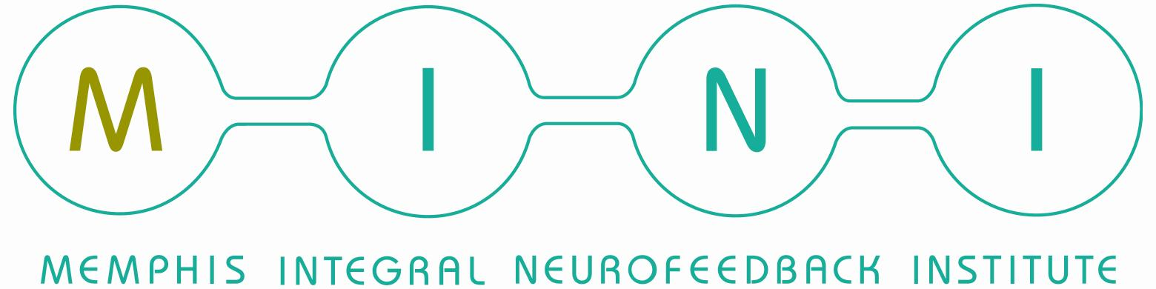
To find out more, please contact us at:
Memphis neurofeedback, LLC
758 Walnut Knoll Lane Cordova, TN 38018
(901) 624-0100 | info@memphisneurofeedback.com
www.memphisneurofeedback.com

